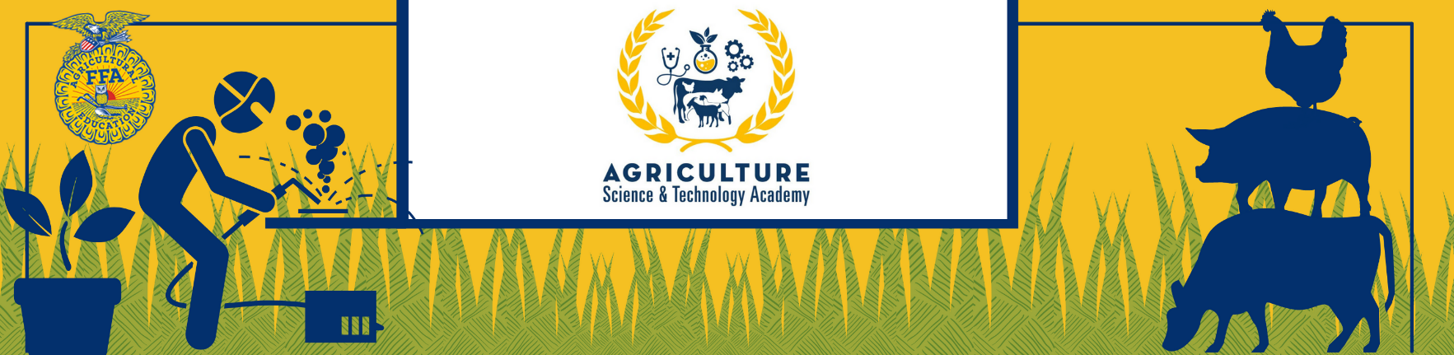

Agriculture Science & Technology Academy
O’Connor FFA Booster Club Benefit Auction
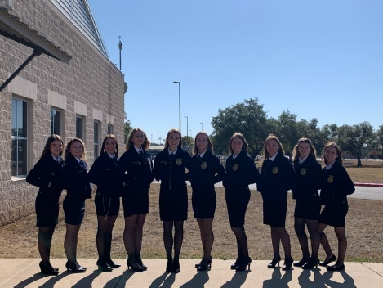
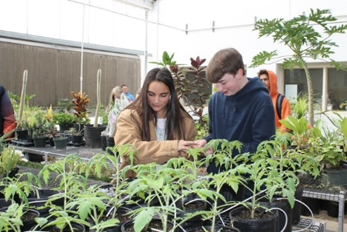
12221 Leslie Road
P.O. Box 781
Helotes, TX 78023
501C - # 23-7336727
Contact for pick-up:
Tara Burkholder
(210) 288-8885

November 9th at
6:30 pm

Supporting more than 600 NISD FFA students in:

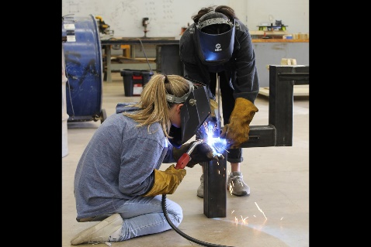
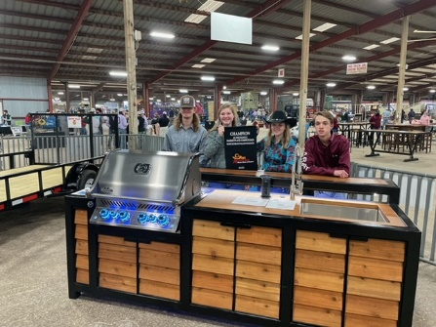
- Leadership Development Events
- Agriculture Mechanics
- Parliamentary Procedure
- Public Speaking Events
- Agriculture Sales & Marketing Plan Development
- Livestock, Meats, Poultry, Equine,
Nursery & Landscaping Judging
- Competitions at State and Nationals
- Workshops and Leadership Camps
- Bexar County and Walter Gerlach Livestock Shows

We would be grateful if you were to consider donating
as they prepare for another successful year!

Mission Statement:
Our Agriculture Science Magnet program provides education and training for many diverse careers in the agricultural field. The program incorporates three elements: classroom instruction, supervised agriculture experiences, and FFA activities. The FFA has the unique characteristic of binding the program together and serving as the catalyst to advance the student more rapidly toward success.

Sandra Day O’Connor FFA Booster Club
Mailing Address: PO Box 781 / 12221 Leslie Road
Helotes, Texas 78023
501 C - #23-7336727
Agriculture Science & Technology Academy High School FFA Program will hold our
Annual Virtual and Live FFA Benefit Silent Auction on Tuesday, November 9th at 6:30 pm

The ASTA Magnet at O’Connor High School provides the only Agriculture Science Program for all of Northside Independent School District, enabling its own students, as well as many others transferring in district-wide, to attend and participate in study for future careers in a diverse group of agriculturally related occupations.
ASTA students are the future in our farming, ranching, food production, fiber, and natural resources industries. Donations from strong community businesses like yours have supported these students in achieving success in skill-building, competition, leadership, and personal growth. We thought you might be interested in knowing the impact community member donations made throughout our 2020-2021 school year:
- LEADERSHIP DEVELOPMENT TEAMS:
Senior Chapter Conducting: 5th at State, Greenhand Chapter Conducting: 7th at Area, Agriculture Issues: 4th at Area, Job Interview: 3rd at State, Public Relations: 9th at Area, Jr. Quiz: 6th at Area, Senior Quiz: 7th at Area, Senior & Junior Creed: 4th at District, Agriculture Advocacy: 5th at Area
- CAREER DEVELOPMENT TEAMS:
Poultry Judging: 3rd at State, Agriculture Sales: 2nd at State, Agriculture Agronomy: 3rd at State, Horse Judging: 17th at State, Livestock Judging: 12th at Area, Farm Business Management: 14th at State, Agriculture Mechanics: 4th at Area, Vet Science: 19th at State, Floral: 12th at State, Dairy Cattle: 10th at State
- WALTER GERLACH STOCK SHOW:
Each year ASTA students experience a best practices program raising Steer, Goats, Lambs, Swine, and Poultry on campus and at home with an opportunity of Showmanship at the Walter Gerlach Stock Show. This instills character building skills of responsibility, dedication, care and a unique, hands-on relationship with the ethical raising of their livestock.
Thank you for your community support. It is deeply appreciated and means the world to all the students, staff, parents and volunteers of the Agriculture Science & Technology Academy FFA.
Sincerely,
Christy Louton
ASTA Auction Coordinator, Sandra Day O’Connor FFA Booster Club

